I'm having issues with one of my recent tags in the field which hasn’t yet been reliable (early reset).

It has an LPS27 pressure sensor and external NOR flash. I built a small jig so I can measure the voltages across a single acquisition cycle and measured both the internal VIN and the VBAT (VBAT feeds VIN through a schottky diode so there's additional voltage drop). Here’s the power circuit:

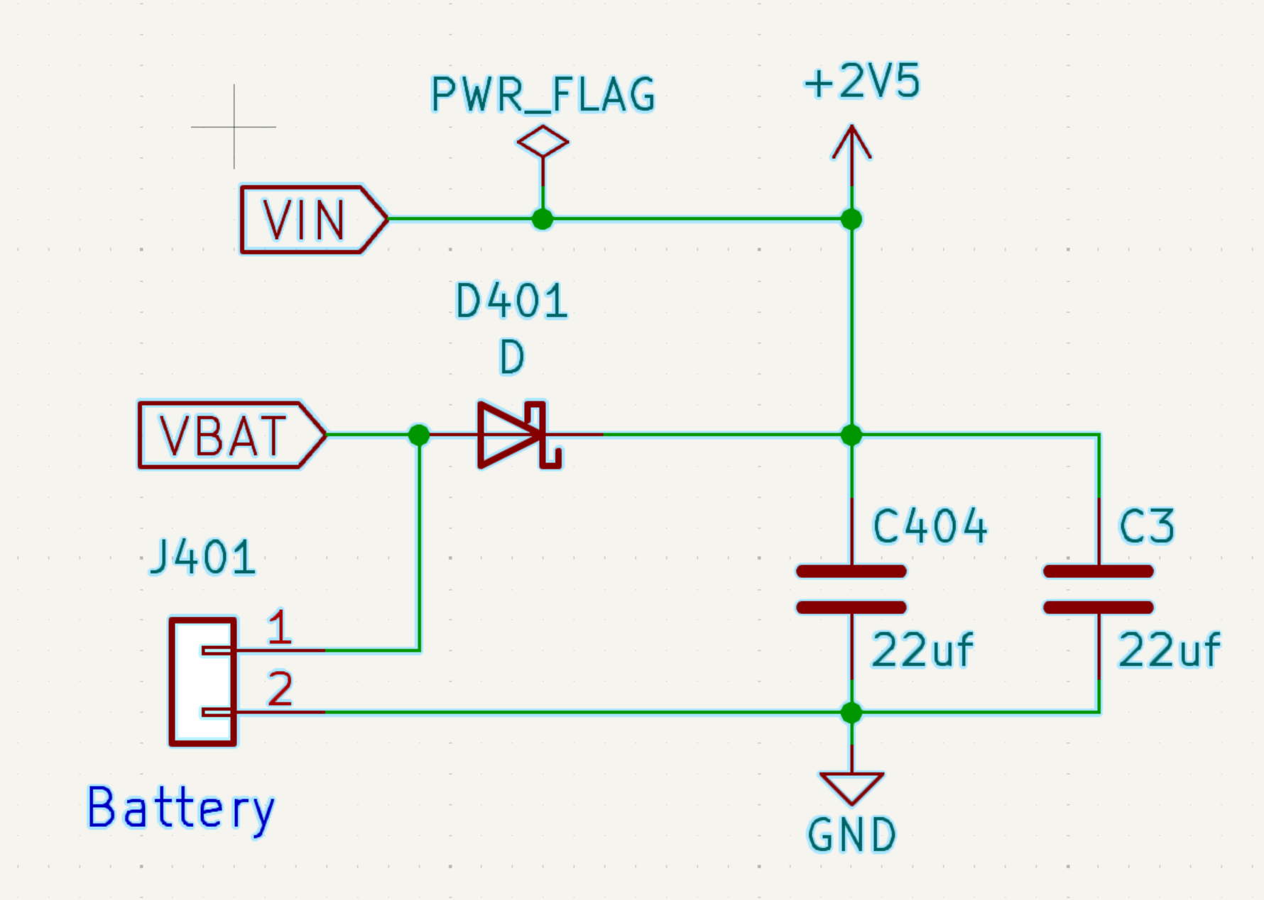

The battery is an MS621FE 5.5mAh LiMg coin cell which has a nominal 2.5 voltage and 80 ohm impedance. It’s rated for maximum 0.25mA continuous current, so the capacitors are important (but a design tradeoff because of leakage).
Here are the Charge/Discharge characteristics for that battery

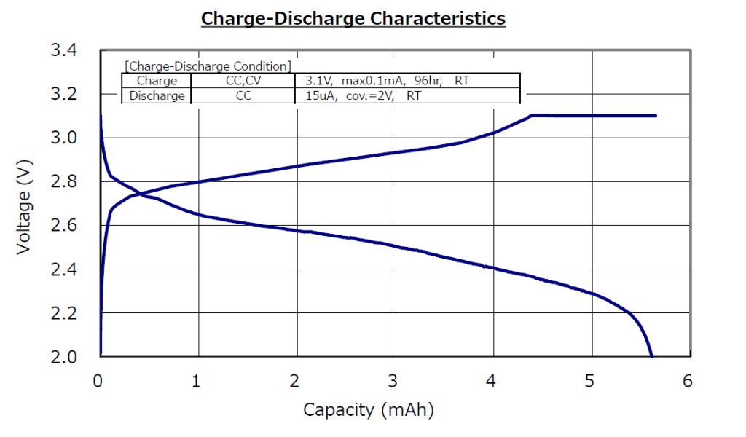
At 2.2 Volts it’s basically discharged.

The minimum voltage requirements of the major circuit elements are:
- stm32l432 : 1.71V
- AT25EX321 Flash: 1.65V
- LPS27 : 1.7V.

So I have (at most) 0.5V of headroom if I want the full 5.5mAh capacity.

Here’s a screen shot measuring the Idle to run voltage at VIN :
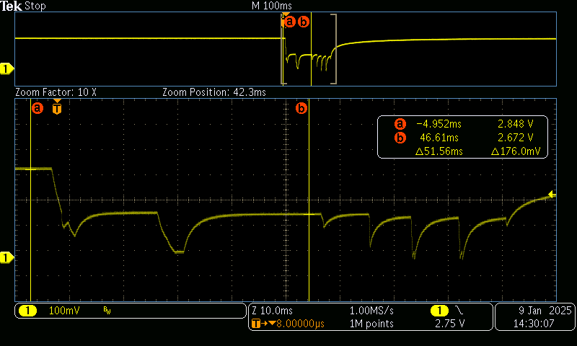

The valleys (from left to right) are:
- Wake up and power up LPS27 pressure sensor
- Start LPS27 acquisition
- Capture LPS27 data (small valley just after B cursor)
- Power up AT25EX321 flash
- Write two bytes
- Write two bytes
- Power down
One of the ways I control power is to provide time for the capacitors to recharge – more capacitance leads to more leakage. Not sure the I have the optimal solution here.
The net voltage drop from idle to run is 176mV – I assume this is primarily diode drop
Here’s the same data measuring idle to flash write: (344mV drop) at VIN:

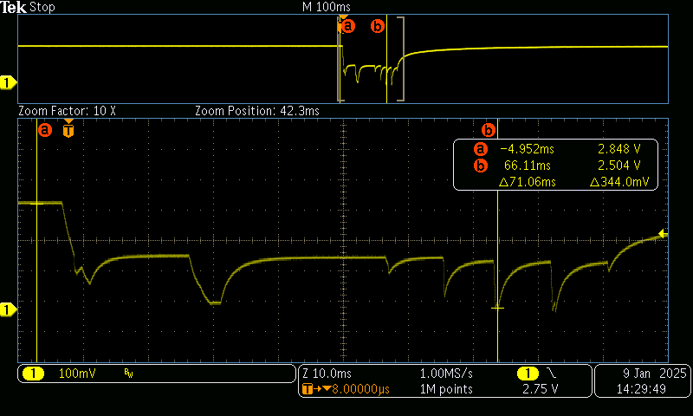
Now looking at VBAT idle to run (no diode drop) -- 56mV

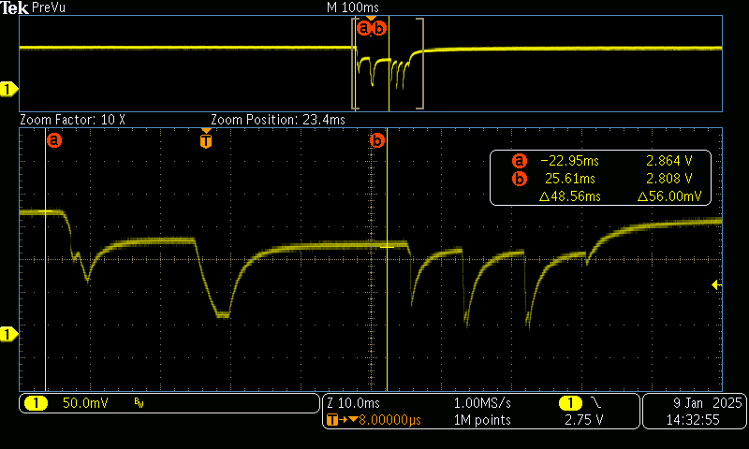
And finally VBAT idle to flash write – 172 mV

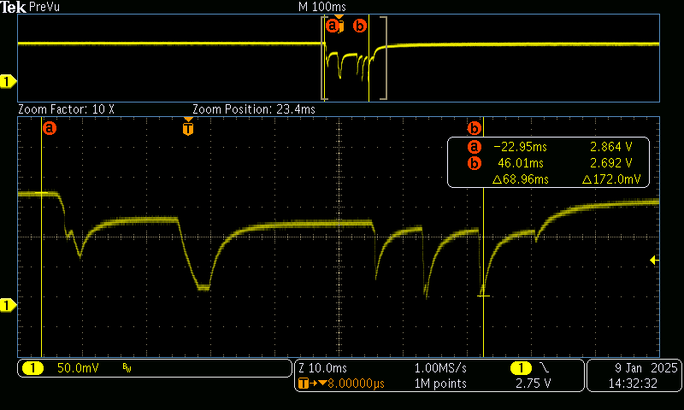
So
I have two options to increase my headroom – add more capacitance or change the way I protect VBAT from VIN (which is powered externally in the programming and charging bases). I have built another prototype tag to replace the BitTag with an additional 47uF capacitor. The leakage seems to be ok. The other choice is to replace the schottky diode with a P-chennel mosfet as in:

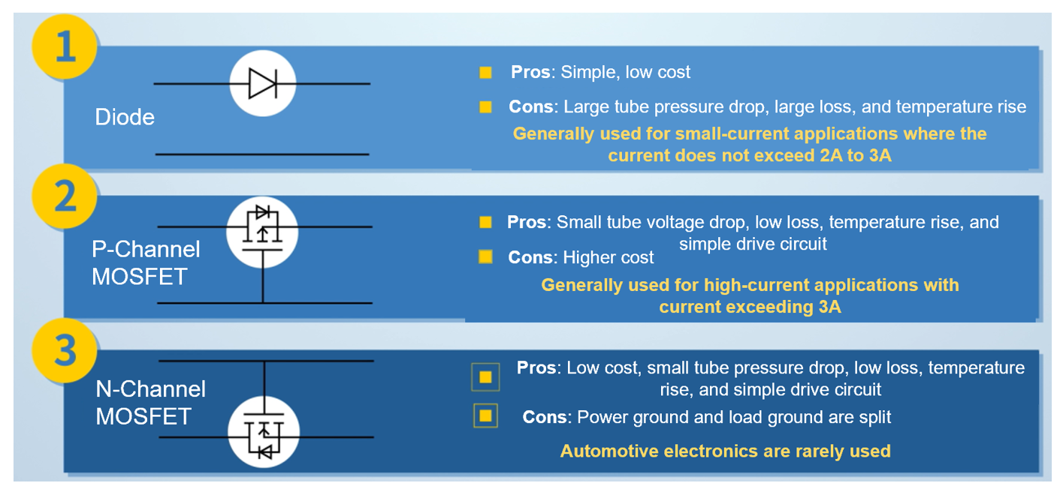
What are your thoughts on this? There are some pretty small p-channel mosfets such as
https://assets.nexperia.com/documents/data-sheet/PMZ350UPE.pdf
I use an n-channel mosfet from this family already. However, I’m not certain there aren’t edge cases that are a problem. For example, a nearly discharged battery (2.2V) and power on VIN (3.3V).

